**Project Overview: Table Reservation Feature for Little Lemon Restaurant**

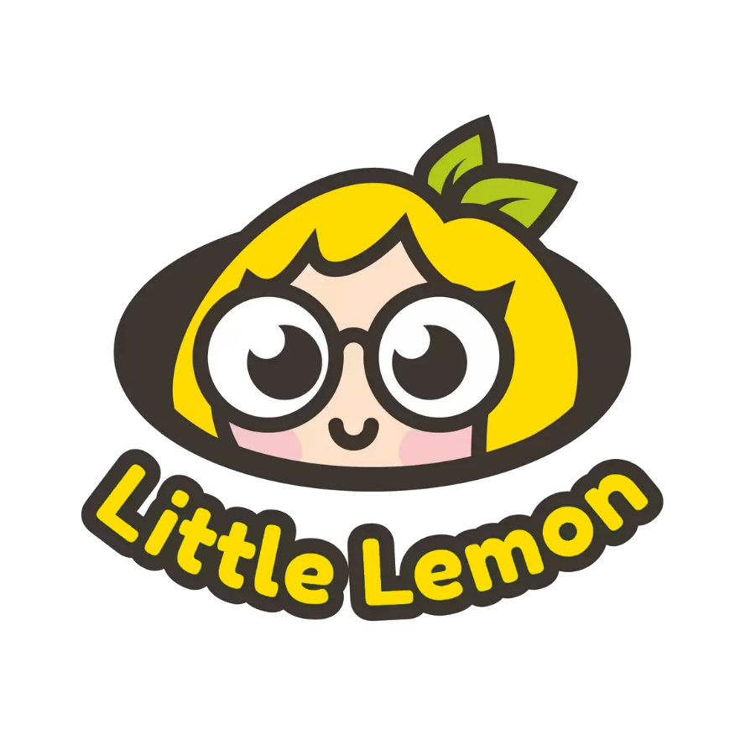

**Greetings everyone**!

The objective of this project entails the creation of a table reservation feature for the app of a fictitious restaurant named Little Lemon. This endeavor serves as the culminating assessment within Meta's Professional Certificate Principles of UX/UI Design Course.

Little Lemon is a quaint Mediterranean restaurant renowned for its blend of traditional recipes infused with contemporary flair.



During this project, I employed **Design Thinking** principles to ensure user-centricity throughout the design process, encompassing the pivotal stages of Empathize, Define, Ideate, Prototype, and Test.

Each phase yielded significant outcomes, leveraging various **UX/UI artifacts** to drive progress:

Crafting a **compelling persona** to anchor the design process around the needs of end-users.

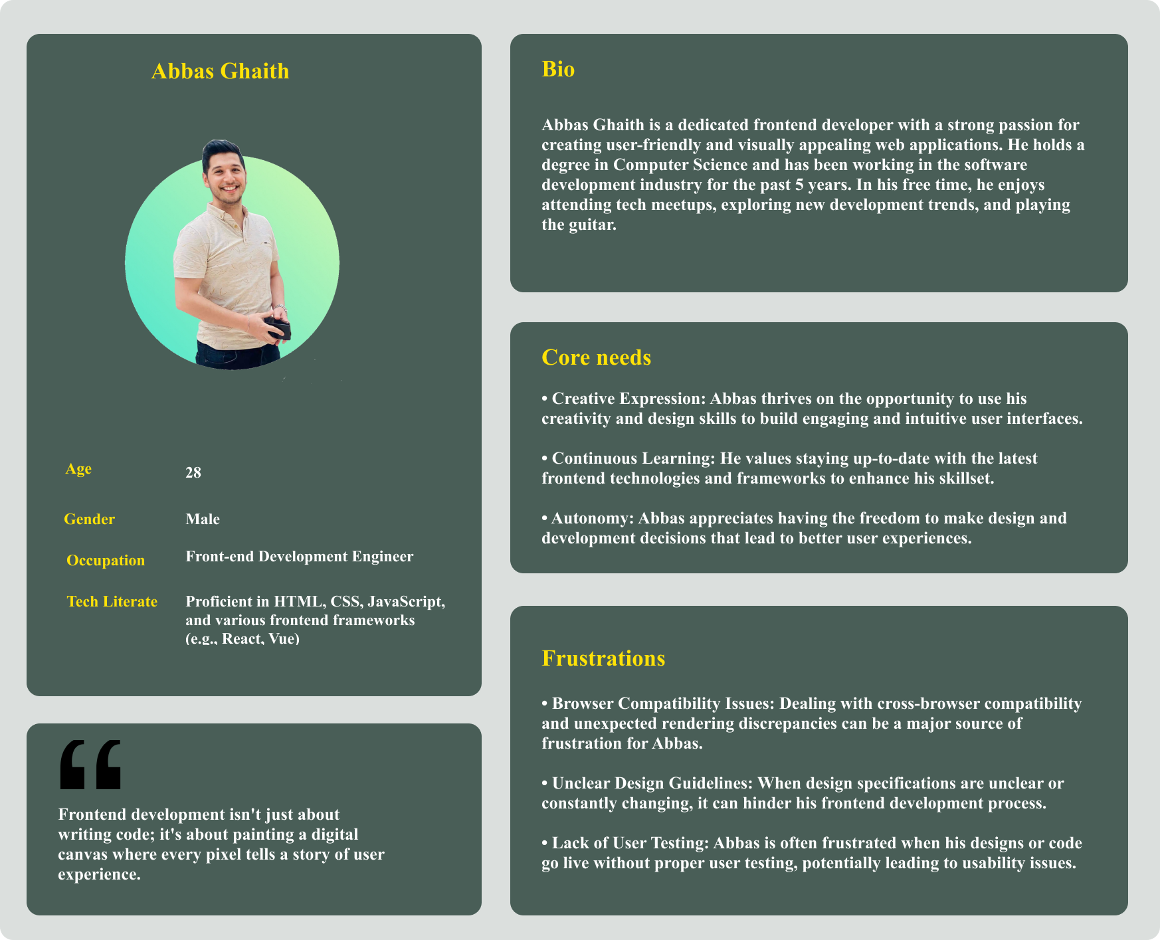

Formulating a concise **problem statement** derived from insights gleaned during the empathize phase.

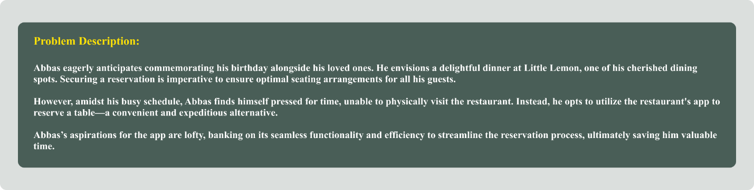

Initiating **wireframe** development using Figma to spark creativity in conceptualizing design solutions.

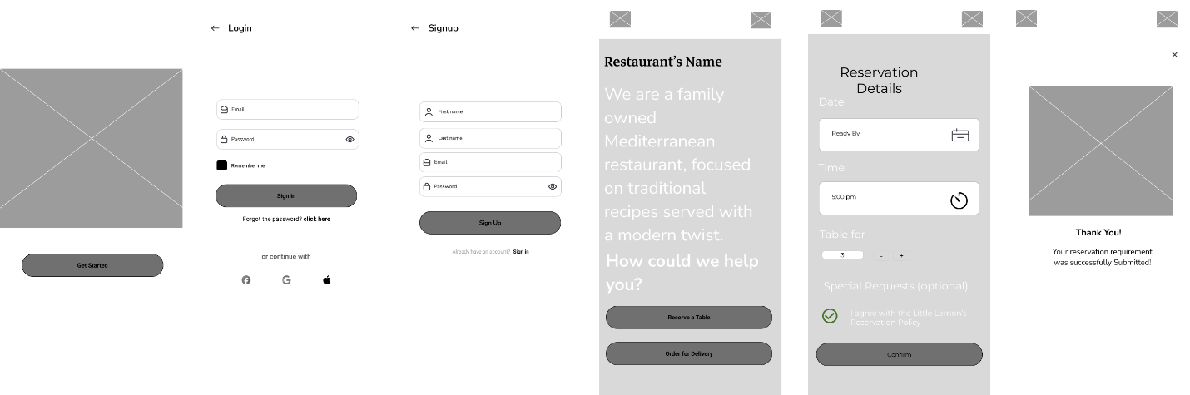

Conducting **journey mapping** exercises to pinpoint potential user pain points and enhance overall usability.

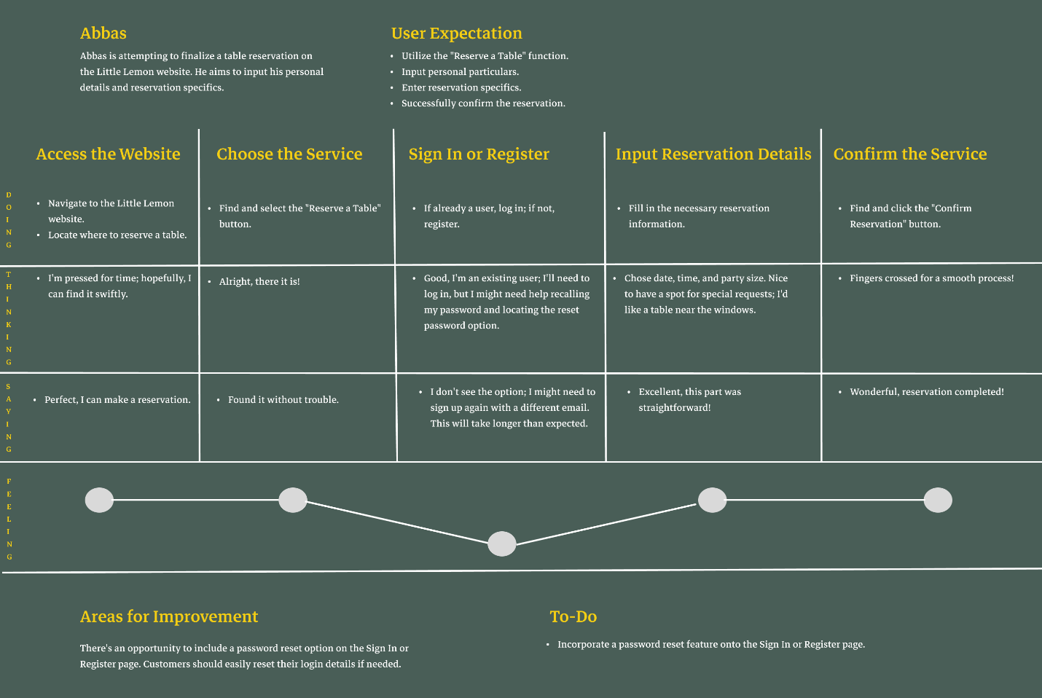

Establishing a **style guide** to curate a visually appealing experience tailored to the target demographic, encompassing the selection of **effects, icons, and imagery** conducive to seamless interaction.

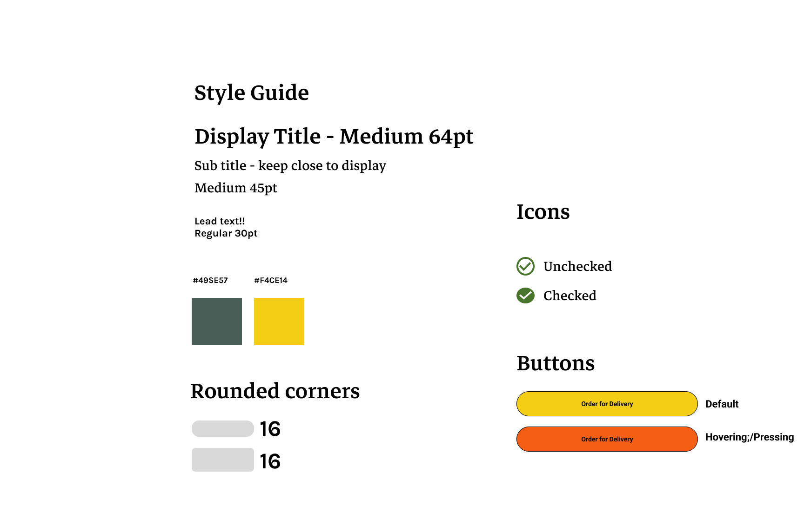

Creating a **high-fidelity prototype** in Figma, incorporating prioritized ideas to refine the envisioned solution.

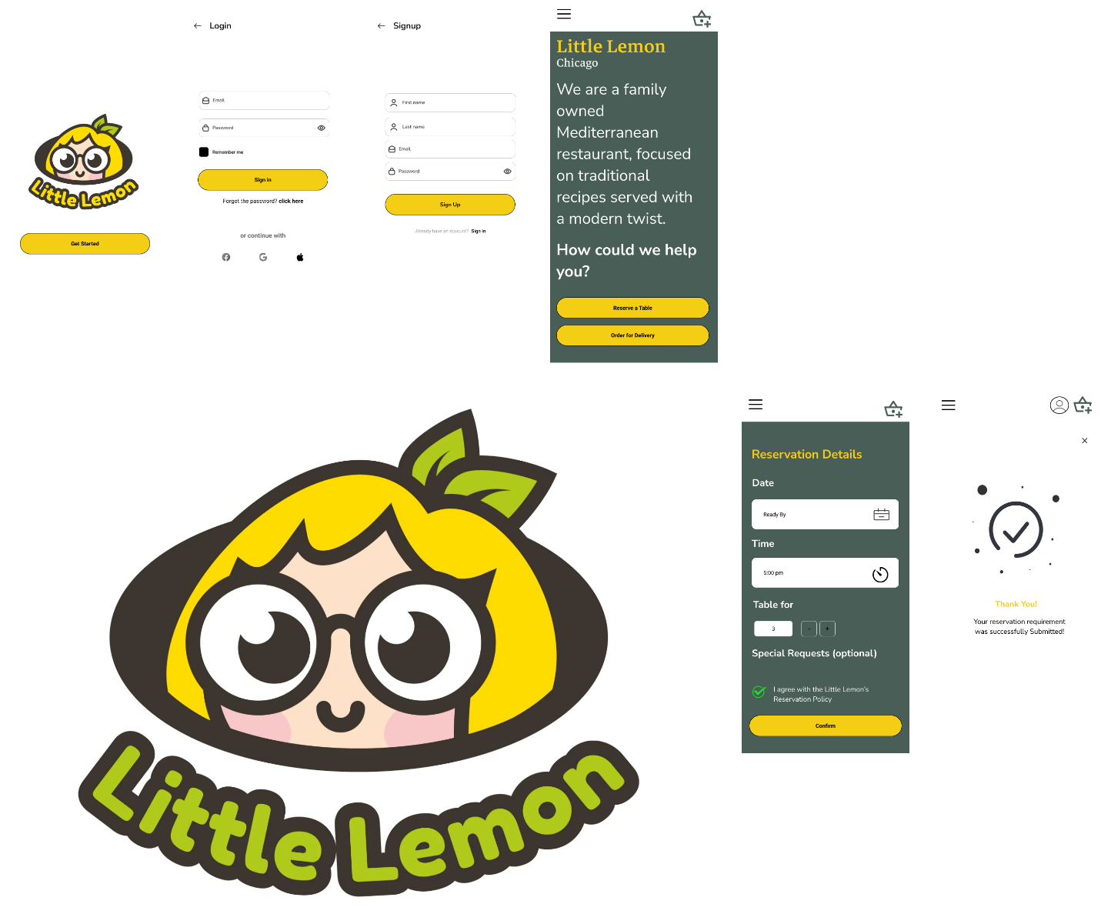

Feel free to **connect with me**:

LinkedIn: [Abbas Ghaith](linkedin.com/in/abbasghaith/)

GitHub Portfolio: [abbasg-dev](https://github.com/abbasg-dev)

Email: abbasghaythy5@gmail.com

Thank you for your attention and interest in this endeavor! 😊